**A Report on Open ended problem titled**

“**DIGITAL STOP WATCH**”

*Submitted for partial fulfillment of III semester Data Structures Laboratory* by

**Team Members:**

VEDASHREE C N 1SI17CS127

VEEKSHA V MURTHY 1SI17CS128



**Department of Computer Science & Engineering**

**Siddaganga Institute of Technology, Tumakuru-3**

(An Autonomous Institution affiliated to Visvesvaraya Technological University, Belgaum, Approved by AICTE, New Delhi)

**2018-19**

**ACKNOWLEDGEMENT**

The completion of the mini project gives me immense happiness and satisfaction by providing me with an opportunity to express my gratitude to everyone who has played an important role in supporting me in my venture, and i would also take a step ahead to thanks everybody else who inspired my actions and work.

**ABSTRACT**

Stopwatches find use as time keeping device in many fields, namely sports. Stopwatches may be analog or digital. Its function is to find out how long it takes in an activity .Digital stopwatches are much more common the analog version owing to their higher accuracy and ease of use. Here we have tried to realize a digital stopwatch of reasonable accuracy and reliability.

This particular stopwatch can count up to 9 minutes and 59.9 seconds .It is accurate up to one tenth of a second. The circuit is relatively simple and easy to realize .The heart of the circuit is an a stable mv followed by counter and decoder stages. The circuit us explained extensively in the following pages.The circuit operates on 5-v dc supply. It uses a seven segment LED display of common anode type to show time

[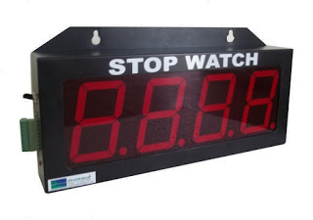](http://4.bp.blogspot.com/-DM-QRgJT38Y/T89C7_MDy5I/AAAAAAAAABQ/EvA1oy_D_rg/s1600/digital+stopwatch.jpg)

Contents

INTRODUCTION______________________________________6

CHAPTER 1

1.1 Block diagram_______________________________________10

1.2 Block diagram explanation_____________________________10

CHAPTER 2

2.1 Circuit diagram______________________________________12

2.2 Hardware Components

2.2.1 Power Supply _____________________________________12

2.2.2 Transfomer_______________________________________ 13

2.2.3 Rectifier__________________________________________14

2.2.4 Voltage regulator___________________________________14

2.2.5 7-Segment Display__________________________________15

2.2.6 BC547 ___________________________________________21

2.2.7 Microcontroller ____________________________________25

CHAPTER 3

3.1 Software Description_________________________________32

CHAPTER 4

4.1 Source Code________________________________________37

CHAPTER 5

5.1 Application_________________________________________45

CONCLUSION________________________________________45

REFERENCES ________________________________________45

**INTRODUCTION**

**DIGITAL STOPWATCH DESCRIPTION**

**STOPWATCHES:-**

Stopwatches can be classified into two categories, Type I and Type II. In general, stopwatches are classified as Type I if they have a digital design employing quartz oscillators and electronic circuitry to measure time intervals (Figure 2). Type II stopwatches have an

analog design and use mechanical mechanisms to measure time intervals (Figure 3). Key

elements of Type I and Type II stopwatches are summarized in Table.

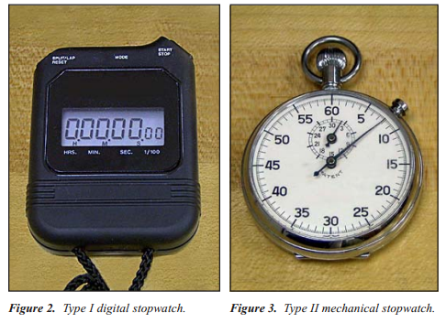

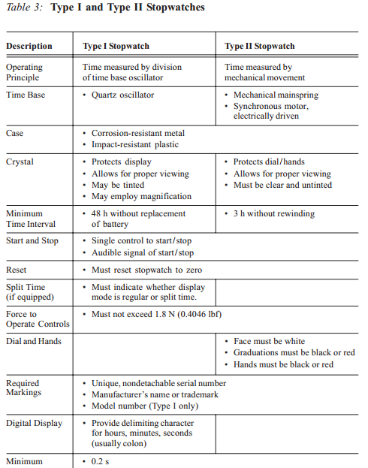

**ASIC THEORY OF OPERATION**

Every stopwatch is composed of four elements: a power source, a time base, a counter, and an indicator or display. The design and construction of each component depends upon the type of stopwatch. Digital (Type I) Stopwatches — The power source of a type I stopwatch is usually a silver cell or alkaline battery, which powers the oscillator, counting and display circuitry. The time base is usually a quartz crystal oscillator, with a nominal frequency of 32 768 Hz (215 Hz). Figure 4 shows the inside of a typical device, with the printed circuit board, quartz crystal oscillator, and battery visible. The counter circuit consists of digital dividers that count the time base oscillations for the period that is initiated by the start/stop buttons. The display typically has seven or eight digits.

**TIMERS**

Timers, unlike stopwatches, count down from a preset time period instead of counting up from zero. They can be small, battery-operated devices that are used to signal when a certain time period has elapsed, or they can be larger devices that plug into a wall outlet and control other items (Figure 6). A parking meter is an example of a countdown timer. Inserting a coin starts the internal timer counting down from an initial preset point. When the time has elapsed, the “EXPIRED” flag is raised. One type of timer used extensively in industry is the process control timer. As their name implies, these devices measure or control the duration of a specific process. For example, when a product is made, it may need to be heat treated for a specific length of time. In an automated manufacturing system, the process control timer determines the amount of time that the item is heated. In some applications, such as integrated circuit manufacturing, the timing process can be critical for proper operation.

Process control timers are also used in many different types of laboratory environments. Calibration laboratories use timers to calibrate units such as radiation detectors, where they regulate the amount of time the detector is exposed to the radiation source. Any uncertainty in the time of exposure directly influences the uncertainty of the detector calibration. Timers are also used in the medical field. For example, medical laboratories use process control timers when specimen cultures are grown. Hospitals use timers to regulate the amount of medication given to patients intravenously.

**ABSOLUTE ACCURACY SPECIFICATIONS:**

The absolute accuracy2 of an instrument is the maximum allowable offset from nominal. Absolute accuracy is defined in either the same units or a fractional unit quantity of the measurement function for an instrument. For example, the absolute accuracy of a ruler might be specified as ±1 mm for a scale of 0 to 15 cm. In the case of timing devices, it isn’t useful to provide an absolute accuracy specification by itself. This is because a device’s time offset from nominal will increase as a function of time. If the timing device were able to measure an infinite time interval, the offset (or difference in time from nominal) of the device would also become infinitely large. Because of this, when timing devices are specified with an absolute accuracy number, it is also accompanied by a time interval for which this specification is valid. An example of this is the specifications for the stopwatch shown in Figure 7, specified with an absolute accuracy of 5 s per day. If the stopwatch in Figure 7 were used to measure a longer time interval, we could determine a new absolute accuracy figure by simply multiplying the original specification by the desired time interval. For example, 5 s per day becomes 10 s per two days, 35 s per week, and so on.

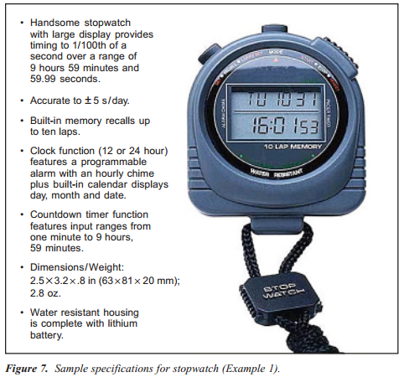While it is usually acceptable to multiply the absolute accuracy by time intervals longer than the period listed in the specifications, we must use caution when dividing the absolute accuracy specification for periods of time shorter than the period listed in the specifications. If we divide the absolute accuracy specification for shorter measurement periods, a new source of uncertainty, the resolution uncertainty of the instrument, becomes important to consider. For example, if we try to determine the accuracy of the stopwatch of Figure 7 for a period of 30 s, we can compute the absolute accuracy as follows:

**CHAPTER – 1**

**METHODOLOGY**

* 1. **BLOCK DIAGRAM**

Switch

MICRO-

CONTROLLER

(89S52)

SEVEN SEGMENT DISPLAY(4-DIGIT)

5V DC Supply

* 1. **BLOCK DIAGRAM EXPLANATION**

**MICROCONTROLLER**

  Microcontroller provides a great advantage that a program is stored in ROM that has an important role in managing the system's operations and functions. Since the program written into ROM is fixed that is, it cannot be altered or changed; as a result the operation of the system remains constant (unchanged) regardless of the instructions given to it. Hence, a microcontroller can be thought of a device containing on-chip program memory.

**VOLTAGE SOURCE (VDD=5V)**

A voltage source is a two terminal device which can maintain a fixed voltage. An ideal voltage source can maintain the fixed voltage independent of the load resistance or the output current. However, a real-world voltage source cannot supply unlimited current. A voltage source is the dual of a current source. Real-world sources of electrical energy, such as batteries, generators, and power systems, can be modeled for analysis purposes as a combination of an ideal voltage source and additional combinations of impedance elements.

**SWITCHES**

Some switches are connected to this microcontroller for controlling its working. These switches are for play, pause and for selection of modes that have to be followed by the microcontroller. switches are used to control the display drivers of the 7segment display.

**7-SEGMENT DISPLAY:**

A seven-segment display or seven-segment indicator, is a form of electronic display

device for displaying decimal numerals that is an alternative to the more complex dot matrix

displays. Seven-segment displays are widely used in digital clocks, electronic meters, and

other electronic devices for displaying numerical information**.**

**CHAPTER-2**

* 1. **CIRCUIT DIAGRAM**

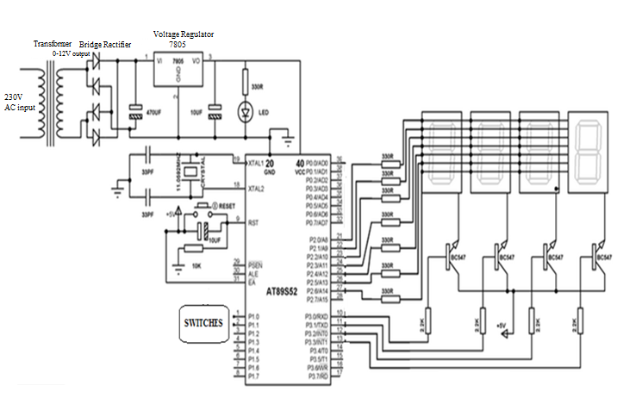

* 1. **HARDWARE DESCRIPTION**
     1. **Power supply**

As the microcontroller operating voltage is +5V DC. Through this power supply circuit we have to create a +5V DC which is given to the micro controller. The below components are used to create the power supply

Regulator 7805

Filter

Bridge rectifier

Step down transformer

230V AC supply

Fig 3.1.1: Block Diagram of Power Supply

**Description**:

230V AC supply is given to the step down transformer of 12A type. It may be a 230V to 9V or 12V step down transformer. The output of the step down transformer is given to bridge rectifier. The bridge rectifier is formed with 1N4007 diodes. The bridge rectifier converts the AC Voltage into DC Voltage. But the output DC Voltage contains some AC component (ripples). So we use a capacitors-2200uF/25V, 0.1uF/D and resistor of 10K as a filter for removing ripples. That output DC Voltage is given to the positive voltage regulator LM7805 (i.e., 78 represents the positive series and 5 represent the output voltage it can provide). So the output of the regulator will be the regulated +5V DC. To indicate the condition of the circuit we place a LED at the end of the circuit.

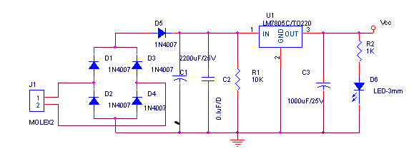

Fig 3.1.1: Schematic of Power Supply

**2.2.2 Transformer**

Transformer is a device used to increment or decrement the input voltage given as per the requirement. The transformers are classified into two types depending upon their functionality. They are Step up transformer and Step down transformer.

In our project, we made use of step down transformer for stepping down the house hold ac power supply i.e. the 230-240V power supply to 12 V.

**2.2.3 Rectifier**

The output of the transformer is AC and should be rectified to a constant DC .For this, it is necessary to feed the output of the transformer to a rectifier. The rectifier is employed to convert the alternating ac to a constant dc.

The rectification is done by using one or more diodes connected in series or parallel. If only one diode is used then only first half cycle is rectified and it is termed as half wave rectification and the rectifier used is termed as Half-wave rectifier**.**

If two diodes are employed in parallel then both positive and negative half cycles are rectified and this is full wave rectification and the rectifier is termed as Full-wave rectifier**.**

If the diodes are arranged in the form of bridge then it is termed as Bridge rectifier .It acts as a full wave rectifier. In our project we have employed a bridge Rectifier.

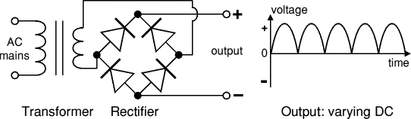

Fig 3.1.2.1: bridge rectifier circuit

**2.2.4 Voltage Regulator**

Voltage regulators comprise a class of widely used ICs. Regulator IC units contain the circuitry for reference source, comparator amplifier, control device, and overload protection all in a single IC. IC units provide regulation of either a fixed positive voltage, a fixed negative voltage, or an adjustably set voltage. A fixed three-terminal voltage regulator has an unregulated dc input voltage, Vi, applied to one input terminal, a regulated dc output voltage, Vo, from a second terminal, with the third terminal connected to ground.

The series 78 regulators provide fixed positive regulated voltages from 5 to 24 volts. Similarly, the series 79 regulators provide fixed negative regulated voltages from 5 to 24 volts.

**IC Voltage Regulators**

Voltage regulator ICs are available with fixed (typically 5, 12 and 15V) or variable output voltages. They are also rated by the maximum current they can pass. Negative voltage regulators are available, mainly for use in dual supplies. Most regulators include some automatic protection from excessive current ('overload protection') and overheating ('thermal protection').

Many of the fixed voltage regulator ICs has 3 leads and look like power transistors,

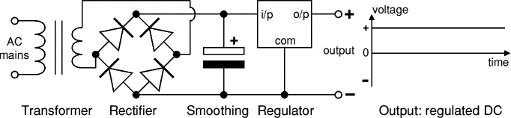

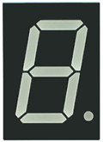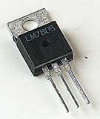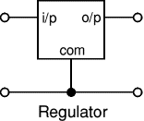

**2.2.5. THE 7-SEGMENT DISPLAY**

An LED or Light Emitting Diode, is a solid state optical PN-junction diode which emits light energy in the form of “photons” when it is forward biased by a voltage allowing current to flow across its junction, and in Electronics we call this process electroluminescence.

The actual colour of the visible light emitted by an LED, ranging from blue to red to orange, is decided by the spectral wavelength of the emitted light which itself is dependent upon the mixture of the various impurities added to the semiconductor materials used to produce it.

[LED’s](http://amazon.in/s/?field-keywords=Light-Emitting+Diodes) have many advantages over traditional bulbs and lamps, with the main ones being their small size, long life, various colours, cheapness and are readily available, as well as being easy to interface with various other electronic components and digital circuits.

But the main advantage of light emitting diodes is that because of their small die size, several of them can be connected together within one small and compact package producing what is generally called a **7-segment Display**.

The 7-segment display, also written as “seven segment display”, consists of seven LEDs (hence its name) arranged in a rectangular fashion as shown. Each of the seven LEDs is called a segment because when illuminated the segment forms part of a numerical digit (both Decimal and Hex) to be displayed. An additional 8th LED is sometimes used within the same package thus allowing the indication of a decimal point, (DP) when two or more 7-segment displays are connected together to display numbers greater than ten.

Each one of the seven LEDs in the display is given a positional segment with one of its connection pins being brought straight out of the rectangular plastic package. These individually LED pins are labelled from a through to g representing each individual LED. The other LED pins are connected together and wired to form a common pin.

So by forward biasing the appropriate pins of the LED segments in a particular order, some segments will be light and others will be dark allowing the desired character pattern of the number to be generated on the display. This then allows us to display each of the ten decimal digits 0 through to 9 on the same 7-segment display.

The displays common pin is generally used to identify which type of 7-segment display it is. As each LED has two connecting pins, one called the “Anode” and the other called the “Cathode”, there are therefore two types of LED 7-segment display called: **Common Cathode** (CC) and **Common Anode** (CA).

The difference between the two displays, as their name suggests, is that the common cathode has all the cathodes of the 7-segments connected directly together and the common anode has all the anodes of the 7-segments connected together and is illuminated as follows.

Common Cathode 7-segment Display:

1. The Common Cathode (CC) – In the common cathode display, all the cathode connections of the LED segments are joined together to logic “0″ or ground. The individual segments are illuminated by application of a “HIGH”, or logic “1″ signal via a current limiting resistor to forward bias the individual Anode terminals (a-g).

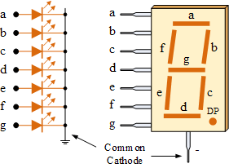

 2. The Common Anode (CA) – In the common anode display, all the anode connections of the LED segments are joined together to logic “1″. The individual segments are illuminated by applying a ground, logic “0″ or “LOW” signal via a suitable current limiting resistor to the Cathode of the particular segment (a-g).

Common Anode 7-segment Display

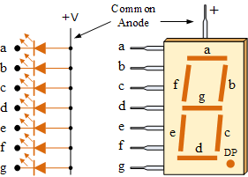

In general, common anode displays are more popular as many logic circuits can sink more current than they can source. Also note that a common cathode display is not a direct replacement in a circuit for a common anode display and vice versa, as it is the same as connecting the LEDs in reverse, and hence light emission will not take place.

Depending upon the decimal digit to be displayed, the particular set of LEDs is forward biased. For instance, to display the numerical digit 0, we will need to light up six of the LED segments corresponding to a, b, c, d, e and f. Then the various digits from 0 through 9 can be displayed using a 7-segment display as shown. 7-Segment Display Segments for all Numbers.

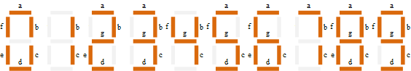

Then for a 7-segment display, we can produce a truth table giving the individual segments that need to be illuminated in order to produce the required decimal digit from 0 through 9 as shown below. 7-segment Display Truth Table

|  |  |  |  |  |  |  |  |
| --- | --- | --- | --- | --- | --- | --- | --- |
| **Decimal Digit** | **Individual Segments Illuminated** | | | | | | |
| **a** | **b** | **c** | **d** | **e** | **f** | **g** |
| 0 | × | × | × | × | × | × |  |
| 1 |  | × | × |  |  |  |  |
| 2 | × | × |  | × | × |  | × |
| 3 | × | × | × | × |  |  | × |
| 4 |  | × | × |  |  | × | × |
| 5 | × |  | × | × |  | × | × |
| 6 | × |  | × | × | × | × | × |
| 7 | × | × | × |  |  |  |  |
| 8 | × | × | × | × | × | × | × |
| 9 | × | × | × | × |  | × | × |

Driving a 7-segment Display

Although a 7-segment display can be thought of as a single display, it is still seven individual LEDs within a single package and as such these LEDs need protection from overcurrent. LEDs produce light only when it is forward biased with the amount of light emitted being proportional to the forward current.

This means then that an LEDs light intensity increases in an approximately linear manner with an increasing current. So this forward current must be controlled and limited to a safe value by an external resistor to prevent damage to the LED segments.

The forward voltage drop across a red LED segment is very low at about 2-to-2.2 volts, (blue and white LEDs can be as high as 3.6 volts) so to illuminate correctly, the LED segments should be connected to a voltage source in excess of this forward voltage value with a series resistance used to limit the forward current to a desirable value.

Typically for a standard red coloured 7-segment display, each LED segment can draw about 15 mA to illuminated correctly, so on a 5 volt digital logic circuit, the value of the current limiting resistor would be about 200Ω (5v – 2v)/15mA, or 220Ω to the nearest higher preferred value.

So to understand how the segments of the display are connected to a 220Ω current limiting resistor consider the circuit below.

Driving a 7-segment Display

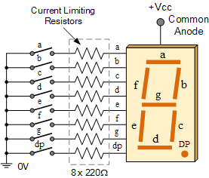

In this example, the segments of a common cathode display are illuminated using the switches. If switch a is closed, current will flow through the “a” segment of the LED to the current limiting resistor connected to pin a and to 0 volts, making the circuit. Then only segment a will be illuminated. So a LOW condition (switch to ground) is required to activate the LED segments on this common anode display.

But suppose we want the decimal number “4″ to illuminate on the display. Then switches b, c, f and g would be closed to light the corresponding LED segments. Likewise for a decimal number “7″, switches a, b, c would be closed. But illuminating 7-segment displays using individual switches is not very practical.

For checking the display you require a simple tool that is your multi-meter. Steps follow while **testing seven segment displays**-

1. Hold the display in your hand and identify the pin 1.This can be done as shown in figure below.

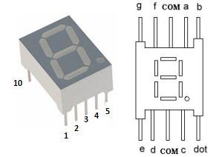

2. Now take multi-meter (Assumption followed red lead for positive and black lead for negative). Set the multi-meter in continuity range.

3. Check for sound test (touch both the leads together sound will produce). Sometimes it may possible, battery of your multi-meter become weak and we will be not being able to get the display.

4. Put the Black lead of multi-meter on pin 3 or 8 both are common pin as they are internally connected.

5. Now put Red lead of multi-meter on any other pin may be 1, 5.

6. If any of the segment glows then your display is common cathode.

7. If none of the segment glows than interchange the leads of multi-meter.

8. Connect the Red lead of multi-meter on pin 3 or pin 8 as both are common pin and internally connected to each other.

9. Now put the black lead of the multi-meter on other remaining pin. If any of the segment glow than your display is common anode, as in common anode positive pin is common and rest are supplied with negative supply.

10. Check all segments of both common cathode and anode to ensure your display is working properly.

11. If none of the segment glows means your 7 segment is faulty.

 I hope this will save your time and energy for identification and let you know **how to test seven segment display**.

**2.2.6 BC547**

The BC547 transistor is an NPN Epitaxial Silicon Transistor. The BC547 transistor is a general-purpose transistor in small plastic packages. It is used in general-purpose switching and amplification BC847/BC547 series 45 V, 100 Ma NPN general-purpose transistors.

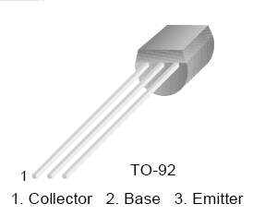

Fig 3.3.1: BC 547 TRANSISTOR PINOUTS

The BC547 transistor is an NPN bipolar transistor, in which the letters “N” and “P” refer to the majority charge carriers inside the different regions of the transistor.

**The Transistor as a Switch**

When used as an AC signal amplifier, the transistors Base biasing voltage is applied in such a way that it always operates within its "active" region, that is the linear part of the output characteristics curves are used. However, both the NPN & PNP type bipolar transistors can be made to operate as "ON/OFF" type solid state switches by biasing the transistors base differently to that of a signal amplifier.

Solid state switches are one of the main applications for the use of transistors, and transistor switches can be used for controlling high power devices such as motors, solenoids or lamps, but they can also used in digital electronics and logic gate circuits.

If the circuit uses the Bipolar Transistor as a Switch, then the biasing of the transistor, either NPN or PNP is arranged to operate the transistor at both sides of the “I-V " characteristics curves we have seen previously.

The areas of operation for a transistor switch are known as the Saturation Region and the Cut-off Region. This means then that we can ignore the operating Q-point biasing and voltage divider circuitry required for amplification, and use the transistor as a switch by driving it back and forth between its "fully-OFF" (cut-off) and "fully-ON" (saturation) regions as shown below.

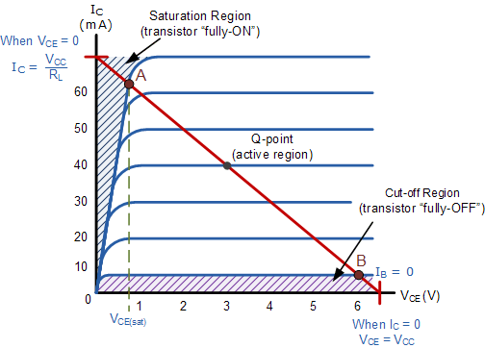

Fig 3.3.2 Transistor Ic Vs. Vce curve

The lower horizontal shaded area at the bottom of the curves represents the "Cut-off" region while the upper vertical shaded area to the left represents the "Saturation" region of the transistor. Both these transistor regions are defined as:

1. Cut-off Region

Here the operating conditions of the transistor are zero input base current ( IB ), zero output collector current ( IC ) and maximum collector voltage ( VCE ) which results in a large depletion layer and no current flowing through the device. Therefore the transistor is switched "Fully-OFF".

Cut-off Characteristics

|  |  |
| --- | --- |
| Cut-off Transistor | The input and Base are grounded ( 0v )   * Base-Emitter voltage VBE < 0.7v * Base-Emitter junction is reverse biased * Base-Collector junction is reverse biased * Transistor is "fully-OFF" ( Cut-off region ) * No Collector current flows ( IC = 0 ) * VOUT = VCE = VCC = "1" * Transistor operates as an "open switch" |

Then we can define the "cut-off region" or "OFF mode" when using a bipolar transistor as a switch as being, both junctions reverse biased, VB < 0.7v and IC = 0. For a PNP transistor, the Emitter potential must be negative with respect to the Base.

2. Saturation Region

Here the transistor will be biased so that the maximum amount of base current is applied, resulting in maximum collector current resulting in the minimum collector emitter voltage drop which results in the depletion layer being as small as possible and maximum current flowing through the transistor. Therefore the transistor is switched "Fully-ON".

Saturation Characteristics

|  |  |
| --- | --- |
| Saturation Transistor | * The input and Base are connected to VCC * Base-Emitter voltage VBE > 0.7v * Base-Emitter junction is forward biased * Base-Collector junction is forward biased * Transistor is "fully-ON" ( saturation region ) * Max Collector current flows ( IC = Vcc/RL ) * VCE = 0 ( ideal saturation ) * VOUT = VCE = "0" * Transistor operates as a "closed switch" |

Then we can define the "saturation region" or "ON mode" when using a bipolar transistor as a switch as being, both junctions forward biased, VB > 0.7v and IC = Maximum. For a PNP transistor, the Emitter potential must be positive with respect to the Base.

Then the transistor operates as a "single-pole single-throw" (SPST) solid state switch. With a zero signal applied to the Base of the transistor it turns "OFF" acting like an open switch and zero collector current flows. With a positive signal applied to the Base of the transistor it turns "ON" acting like a closed switch and maximum circuit current flows through the device.

In our circuit we use a transistor as a switch for every single 7 segment display in order to control the display, the frequency of switching the display on/off is so rapid that the human eye doesn’t identify the on/off period.

The transistor’s base is connected to the microcontroller to control the switching of display continuously. The clock cycle of on/off of the display from the microcontroller is sent through base.

**2.2.7 Microcontroller (AT89S52)**

**Features**

• Compatible with MCS-51Products

• 8K Bytes of In-System Programmable (ISP) Flash Memory

• 4.0V to 5.5V Operating Range

• Fully Static Operation: 0 Hz to 33 MHz

• 256Bytes Internal RAM

• 32 Programmable I/O Lines

• 3 16-bit Timer/Counters

• Full Duplex UART Serial Channel

**Description of microcontroller AT 89s52:**

The AT89S52 is a low-power, high-performance CMOS 8-bit micro controller with 8Kbytes of in-system programmable Flash memory. The device is manufactured

Using Atmel’s high-density non-volatile memory technology and is compatible with the industry-standard 80C51 micro controller. The on-chip Flash allows the program memory to be reprogrammed in-system or by a conventional non-volatile memory programmer. By combining a versatile 8-bit CPU with in-system programmable flash one monolithic chip; the Atmel AT89S52 is a powerful micro controller, which provides a highly flexible and cost- effective solution to many embedded control applications.

The AT89S52 provides the following standard features: 8K bytes of Flash, 256 bytes of RAM, 32 I/O lines, Watchdog timer, two data pointers, three 16-bit timer/counters, full duplex serial port, on-chip oscillator, and clock circuitry. In addition, the AT89S52 is designed with static logic for perationdown to zero frequency and supports two software selectable power saving modes. The Idle Mode stops the CPU while allowing the RAM timer/counters, serial port, and interrupt system to continue functioning. The Power-down mode saves the RAM contents but freezes the oscillator, disabling all other chip functions until the next interrupt or hardware reset.

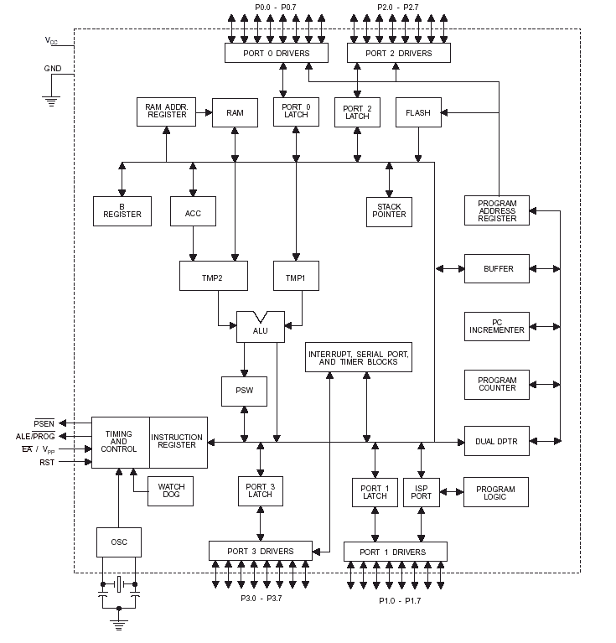

Fig 3.4.1 Architecture of 89S52

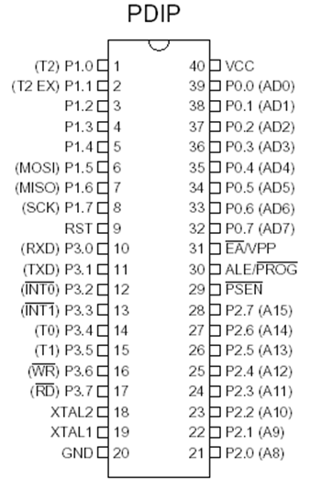

Fig. 3.4.2 Pin diagram of 89S52

**Pin Description of microcontroller AT89S52**

**VCC:** Supply voltage.

**GND:** Ground.

**Port 0**

Port 0 is an 8-bit open drain bidirectional I/O port. As an output port, each pin can sink eight TTL inputs. When 1s are written to port 0 pins, the pins can be used as high-impedance inputs. Port 0 can also be configured to be the multiplexed low-order address/data bus during accesses to external program and data memory. In this mode, P0 has internal pull-ups. Port 0 also receives the code bytes during Flash programming and outputs the code bytes during program verification. External pull-ups are required during program verification.

**Port 1**

Port 1 is an 8-bit bidirectional I/O port with internal pull-ups. The Port 1 output buffers can sink/source four TTL inputs. When 1s are written to Port 1 pins, they are pulled high by the internal pull-ups and can be used as inputs. As inputs, Port 1 pins that are externally being pulled low will source current (IIL) because of the internal pull-ups. In addition, P1.0 and P1.1 can be configured to be the timer/counter 2 external count input (P1.0/T2) and the timer/counter 2 trigger input (P1.1/T2EX), respectively, as shown in the following table.

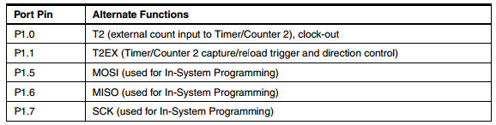

Table 3.4.1: The Alternate Functions of Port 1 Pins

Port 1 also receives the low-order address bytes during Flash programming and verification.

**Port 2**

Port 2 is an 8-bit bidirectional I/O port with internal pull-ups. The Port 2 output buffers can sink/source four TTL inputs. When 1s are written to Port 2 pins, they are pulled high by the internal pull-ups and can be used as inputs. As inputs, Port 2 pins that are externally being pulled low will source current (IIL) because of the internal pull-ups.Port 2 emits the high-order address byte during fetches from external program memory and during accesses to external data memory that use 16-bit addresses (MOVX @ DPTR). In this application, Port 2 uses strong internal pull-ups when emitting 1s. During accesses to external data memory that use 8-bit addresses (MOVX @ RI), Port 2 emits the contents of the P2 Special Function Register.

Port 2 also receives the high-order address bits and some control signals during Flash programming and verification.

**Port 3**

Port 3 is an 8-bit bidirectional I/O port with internal pull-ups. The Port 3 output buffers can sink/source four TTL inputs. When 1s are written to Port 3 pins, they are pulled high by the internal pull-ups and can be used as inputs. As inputs, Port 3 pins that are externally being pulled low will source current (IIL) because of the pull-ups.

Port 3 receives some control signals for Flash programming and verification.

Port 3 also serves the functions of various special features of the AT89S52, as shown in the following table.

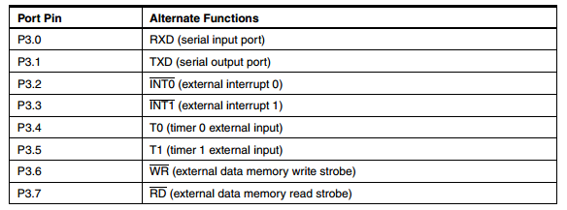

Table 2.2.2: Alternate Functions of Port 3 Pins

**Port Usages in project:**

**Port Description for timer:**

Port 1 pins are connected to Decoder (4 bits), 4 pins i.e. Port1.0, 1.1, 1.2, 1.3

Port 2 pins are connected to seven segment display pins (common anode), i.e. 7 pins in total to each multiplexed display P2.0, 2.1, 2.2, 2.3, 2.4, 2.5, 2.6.

Port 3 pins are connected to seven segment display via Transistors as control lines to pin no. P3.0, 3.1, 3.2, 3.3.

**Port Description for Score:**

Port 1 pins are connected to Decoder (4 bits), 4 pins i.e. Port1.0, 1.1, 1.2, 1.3

Port 2 pins are connected to seven segment display pins (common anode), i.e. 7 pins in total to each multiplexed display P2.0, 2.1, 2.2, 2.3, 2.4, 2.5, 2.6.

Port 3 pins are connected to seven segment display via Transistors as control lines to pin no. P3.0, 3.1, 3.2, 3.3.

**Port Description for team name display:**

Port 1 pins are connected to switch’s 4 switch’s each for each display, 4 pins i.e. Port1.0, 1.1, 1.2, 1.3

Port 2 pins are connected to seven segment display pins (common anode), i.e. 7 pins in total to each multiplexed display P2.0, 2.1, 2.2, 2.3, 2.4, 2.5, 2.6.

Port 3 pins are connected to seven segment display via Transistors as control lines to pin no. P3.0, 3.1, 3.2, 3.3.

**RST:** Reset input. A high on this pin for two machine cycles while the oscillator is running resets the device. Each module in the score board has been provided with its own reset button.

**ALE/PROG:**

Address Latch Enable (ALE) is an output pulse for latching the low byte of the address during accesses to external memory. This pin is also the program pulse input (PROG) during Flash programming. In normal operation, ALE is emitted at a constant rate of1/6 the oscillator frequency and may be used for external timing or clocking purposes. Note, however, that one ALE pulse is skipped during each access to external data Memory. If desired, ALE operation can be disabled by setting bit 0 of SFR location

8EH. with the bit set, ALE is active only during a MOVX or MOVC instruction. Otherwise, the pin is weakly pulled high. Setting the ALE-disable bit has no effect if the micro controller is in external execution mode.

**PSEN:**

Program Store Enable (PSEN) is the read strobe to external program memory. When the AT89S52 is executing code from external program memory, PSEN is activated twice each machine cycle, except that two PSEN activations are skipped during each access to external data memory.

**EA/VPP:**

External Access Enable. EA must be strapped to GND in order to enable the device to fetch code from external program memory locations starting at 0000H up to FFFFH. Note, however, that if lock bit 1 is programmed, EA will be internally latched on reset. A should be strapped to VCC for internal program executions. This pin also receives the 12-voltProgramming enables voltage (VPP) during Flash programming.

**3.4.1 OSCILLATOR**

XTAL1 and XTAL2 are the input and output, respectively, of an inverting amplifier that can be configured for use as an on-chip oscillator. Either a quartz crystal or ceramic resonator may be used. To drive the device from an external clock source, XTAL2 should be left unconnected while XTAL1 is driven, as shown in Figure 2.2.3. There are no requirements on the duty cycle of the external clock signal, since the input to the internal clocking circuitry is through a divide-by-two flip-flop, but minimum and maximum voltage high and low time specifications must be observed.

**XTAL1:**

Input to the inverting oscillator amplifier and input to the internal clock operating circuit.

**XTAL2 :**

Output from the inverting oscillator amplifier.

We have used a 11.0592Mhz crystal oscillator.

**3. Software Description**

3.1 µvision2

µVision2 is an IDE (Integrated Development Environment) that helps us write, compile, and debug embedded programs. It encapsulates the following components:

1. A project manager.
2. A make facility.
3. Tool configuration.
4. Editor.
5. A powerful debugger.

3.1.1 Creating application in µvision2:

1. Select Project - New Project.
2. Select a directory and enter the name of the project file.
3. Select Project - Select Device and select an 8051, 251, or C16x/ST10 device from the Device Database™.
4. Create source files to add to the project.
5. Select Project - Targets, Groups, and Files. Add/Files, select Source Group1, and add the source files to the project.
6. Select Project - Options and set the tool options. when we select the target device from the Device Database all special options are set automatically. We need to configure only the memory map of our target hardware. Default memory model settings are optimal for most applications.
7. Select Project - Rebuild all target files or Build target.

3.1.2 Debugging an application in µvision2:

To debug an application created using µVision2, we must:

1. Select Debug - Start/Stop Debug Session.
2. Use the Step toolbar buttons to single-step through your program. We may enter **G, main** in the Output Window to execute to the main C function.
3. Open the Serial Window using the **Serial #1** button on the toolbar

We can Debug program using standard options like Step, Go, Break, and so on.

**3.1.3 Creating a Project:**

µVision2 is a standard Windows application and started by clicking on the program icon. To create a new project file select from the µVision2 menu

**Project** – New Project…. This opens a standard Windows dialog that asks us for the new project file name. a separate folder should be used for each project. we can simply use the icon Create New Folder in this dialog to get a new empty folder. Then select this folder and enter the file name for the new project, i.e. Project1.

µVision2 creates a new project file with the name PROJECT1.UV2 which contains a default target and file group name. We can see these names in the Project Window – Files.

Now use from the menu Project – Select Device for Target and select a CPU for the project. The Select Device dialog box shows the µVision2 device database. Just select the micro controller we use. For example, we are using the Philips 80C51RD+ CPU. This selection sets necessary tool options for the 80C51RD+ device and simplifies in this way the tool Configuration

**3.1.4 Building projects and creating a hex files:**

Typical, the tool settings under Options – Target are all we need to start a new application. we may translate all source files and line the application with a click on the Build Target toolbar icon. When we build an application with syntax errors, µVision2 will display errors and warning messages in the Output Window – Build page. A double click on a message line opens the source file on the correct location in a µVision2 editor window. Once we have successfully generated our application we can start debugging

After we have tested your application, it is required to create an Intel HEX file to download the software into an EPROM programmer or simulator. µVision2 creates HEX files with each build process when Create HEX files under Options for Target – Output is enabled. We may start our PROM programming utility after the make process when we specify the program under the option Run User Program #1.

**3.1.5 CPU Simulation:**

µVision2 simulates up to 16 Mbytes of memory from which areas can be mapped for read, write, or code execution access. The µVision2 simulator traps and reports illegal memory accesses. In addition to memory mapping, the simulator also provides support for the integrated peripherals of the various 8051 derivatives. The on-chip peripherals of the CPU you have selected are configured from the Device

**3.1.6 Database selection:**

We may select and display the on-chip peripheral components using the Debug menu. We can also change the aspects of each peripheral using the controls in the dialog boxes.

**3.1.7 Start debugging:**

We start the debug mode of µVision2 with the Debug – Start/Stop Debug Session command. Depending on the Options for Target – Debug Configuration, µVision2 will load the application program and run the startup code. µVision2 saves the editor screen layout and restores the screen layout of the last debug session. If the program execution stops, µVision2 opens aneditor window with the source text or shows CPU instructions in the disassembly window. The next executable statement is marked with a yellow arrow. During debugging, most editor features are still available.

For example, we can use the find command or correct program errors. Program source text of the application is shown in the same windows. The project structure or tool parameters cannot be modified. All build commands are disabled.

**3.1.8 Disassembly window:**

The Disassembly window shows the target program as mixed source and assembly program or just assembly code. A trace history of previously executed instructions may be displayed with Debug – View Trace Records. To enable the trace history, set Debug – Enable/Disable Trace Recording.

If we select the Disassembly Window as the active window, all program step commands work on CPU instruction level rather than program source lines. we can select a text line and set or modify code breakpoints using toolbar buttons or the context menu commands.

we may use the dialog Debug – Inline Assembly to modify the CPU instructions. That allows us to correct mistakes or to make temporary changes to the target program you are debugging.

**3.2 KEIL**

Keil compiler is a software used where the machine language code is written and compiled. After compilation, the machine source code is converted into hex code which is to be dumped into the microcontroller for further processing. Keil compiler also supports C language code.

**Flow chart**

Select New project

Create a Project file

Select a Microcontroller

In target, create the source group

Create a new source file

Save the file with the extension .C

Give the relevant parameters to the target

If Error?

On a message line opens the source file on the correct location in a µVision editor window

Click on the Build Target toolbar

Click on Rebuild Target

Create an Intel HEX file

## Fig 4.2.1 Flowchart representing how to use keil uvision to dump the program

**4. Source Code**

**4.1**

**#include<at89s52.h>**

**#include<intrins.h>// for using _nop_() function**

**sbit dig_ctrl_1=P0^0; // Control pins for the seven segments**

**sbit dig_ctrl_2=P0^1;**

**sbit dig_ctrl_3=P0^2;**

**sbit dig_ctrl_4=P0^3;**

**sbit sw1=P1^0;**

**sbit sw2=P1^1;**

**sbit sw3=P1^2;**

**sbit led1=P3^7;**

**unsigned char dig_disp=0,flag = 1,flag1 = 1,flag2 = 1;**

**unsigned char dd1=2,dd2=2,td1=3,td2=4;**

**unsigned char cnt=0,ms=0,ss=0,mm=0,num1=0,num2=0;**

**char digi_val[10]={0x40,0xF9,0x24,0x30,0x19,0x12,0x02,0xF8,0x00,0x10};**

**void msdelay(unsigned int itime)**

**{**

**unsigned int i,j ;**

**for(i=0;i<itime;i++) ;**

**for(j=0;j<1;j++);**

**}**

**void display() interrupt 1 // Function to display the four digit number using multiplexing on seven segment. It uses Timer 0 interrupt to display the four digits one by one after a time delay of 2.5 milli second**

**{**

**TL0=0x36;**

**TH0=0xf6;**

**P2=0xFF;**

**dig_ctrl_1 = dig_ctrl_3 = dig_ctrl_2 = dig_ctrl_4 = 0;**

**dig_disp++;**

**dig_disp=dig_disp%6;**

**if(flag2 == 1)**

**{**

**dd1 = ss/10;**

**dd2 = ss%10;**

**td1 = ms/10;**

**td2 = ms%10;**

**}**

**else**

**{**

**dd1 = mm/10;**

**dd2 = mm%10;**

**td1 = ss/10;**

**td2 = ss%10;**

**}**

**switch(dig_disp)**

**{**

**case 0:**

**P2=digi_val[dd1];**

**dig_ctrl_1 = 1;**

**break;**

**case 1:**

**P2= digi_val[dd2];**

**dig_ctrl_2 = 1;**

**break;**

**case 2:**

**P2= digi_val[td1];**

**dig_ctrl_3 = 1;**

**break;**

**case 3:**

**P2= digi_val[td2];**

**dig_ctrl_4 = 1;**

**break;**

**}**

**}**

**void main()**

**{**

**P2=0xFF;**

**TMOD=0x11; // Intialize Timer 0**

**TL0=0x36;**

**TH0=0xF6;**

**// TH1=0xFC; // initial values loaded to timer**

**// TL1=0x00;**

**IE=0x82;**

**TR0=1; //Start timer0**

**// TR1=1; //Start timer1**

**P1 = 0xFF;**

**while(1) // Forward counting**

**{**

**if(flag == 1)**

**{**

**_nop_();_nop_();_nop_();_nop_();_nop_();**

**_nop_();_nop_();_nop_();_nop_();_nop_();**

**_nop_();_nop_();**

**// msdelay(1);**

**cnt++;**

**if(cnt == 10)**

**ms++;**

**if(ms == 100)**

**{**

**ms = 0;**

**ss++;**

**}**

**if(ss == 60)**

**{**

**ss = 0;**

**mm ++;**

**}**

**if( mm == 60)**

**mm = 0;**

**}**

**if( sw3 == 0 )**

**{**

**if(flag1 ==1 )**

**flag = flag1 = 0;**

**else**

**flag = flag1= 1; msdelay(15);**

**}**

**if(sw1 == 0)**

**{**

**flag2 = 1;**

**}**

**if(sw2 == 0)**

**{**

**flag2 = 0;**

**}**

**}**

**}**

**CHAPTER 5**

**5.1 Applications.**

* Laboratory experiments
* [Sporting events](http://en.wikipedia.org/wiki/Sporting_event)
* Competitions

# Conclusion

After completion of this digital stop watch project i have learnt some knowledge in designing the circuit and understood the coding process. The circuit has been implemented on bread board and soldiered on general purpose PCB. This circuit can operate in two modes with play and pause switches.

# References

1. Kenneth .J. Ayala, The 8051 Microcontroller and its applications, prentice hall, new Edition, 2006. – “about the microcontroller functioning”
2. [www.circuitstoday.com](http://www.circuitstoday.com/) – “basics of Seven segment display , transistor”
3. [www.8051projects.info](http://www.8051projects.info/) – “ about at 89S52 microcontroller”
4. Datasheet’s 434Mhz RF module Rx. Tx. - Cytron Technologies Sdn. Bhd.

7 segment display –LTS 542/543 LITE ON ELECTRONICS, INC.